Annual Report
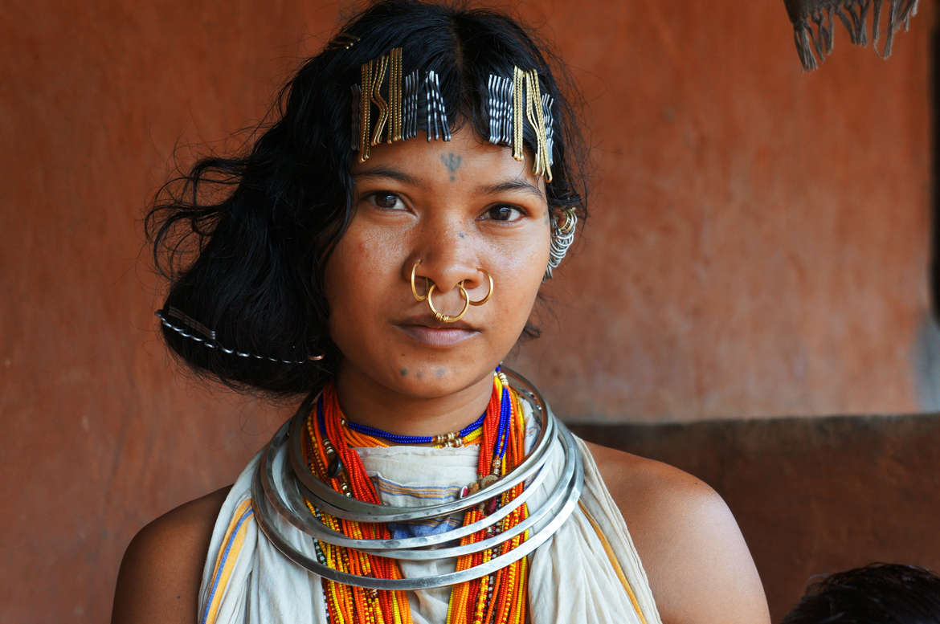
2021-2022

DAPTA
Development Agency for Poor & Tribal Awakening,
Bhawanipatna, Kalahandi
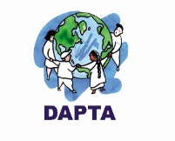

Contents

- Vision, Mission and Geographical Area
- Donor Wise Activities in 2021-22
- Thematic area of Intervention
- Executive Body Details
- Staff Details
- Training Facilities and Trainers Associated with DAPTA
- Legal Entity
- Audited Statement -Attached Separate Sheet.

Secretary’s Desk……….

DAPTA’s strong commitment to uplift poor, tribal and women makes it a distinctive civil society organization. Being associated with DAPTA from its inception gives me immense pleasure, especially when I see the poor, tribal and women becoming more aware of their rights and taking charge of their own development.

I am very glad to present the Annual report of 2021-2022 in which year the organization has completed its 32nd eventful journey. DAPTA, a development support organization, has diversified its journey in sustainable development of down trodden people, marginal community with a special' focus to the development of women, children and tribal people of Kalahandi and other tribal areas of Odisha since its inception.

DAPTA is working on four numbers of issues like Women empowerment', Agriculture and livelihood, Health care, Education child right and Humanitarian supports. Witnessing ground reality ‘we are working with some other network partners. DAPTA usually work for the people with community participation, community involvement and community led evaluation process to lead a sustainable change. This Year DAPTA has covered a large number of women and children mostly in its all project'. I am proud to say that DAPTA has set new goals for the next five years under the Country Strategy-V as a commitment to achieving the Sustainable Development Goals. It aims to bring a positive impact in the lives of the marginalized (poor, tribes, women and transgender) by 2025. This will be achieved through support from key partners including corporates, government, donors and civil society organizations. I am confident that we will achieve this goal.

On behalf of DAPTA, I express my deep gratitude to all our donors like SLCW, Central social Welfare Board. State Social Welfare Board, Azim Premji Foundation, NABARD, OSACS, TDH Germany, Barefoot College, Selco foundation, Smile Foundation, CHILDLINE India Foundation, Habitat India, Jiv Daya Foundation, CHILDLINE India Foundation, SSPD Dept., WCD Dept. Millet Mission, Health Dept. and other donor partners. Moreover, we are grateful to Dist. Administration, Block Administration of Kalahandi and other Dist., NGO partners, WASSAN, CACL, LASK, Credibility Alliance, Guide Star, India Donates, FMSF, individuals, journalists, friends and associates those have supported DAPTA to achieve its objective and to touch the mile stone which is yet to achieve, yet to run miles and miles.........

Raju Sharma
Secretary DAPTA

Vision
DAPTA’s vision is to eradicate poverty from the earth and to provide equal opportunity to all people
DAPTA’s vision is that marginalized poor in India can live without poverty and access to equal opportunities.
Mission
DAPTA’s Mission is to work with marginalized poor to alleviate poverty by overcoming injustice and inequity that causes it and to lead a meaningful life with sustainable protected environment and bio-diversity.
Geographical Area Covered
- Kalahandi District:
Block - 13
Gram Panchayat (G. P) - 97
- Nabrangpur District:
Block - 1
Gram Panchayat (G. P) -1
- Deogarh District
Block – 1
- Nuapada District
- Women Empowerment
- E-SHAKTI
- FCC (Family Counselling Centre)
- Domestic violence and adolescent trafficking
- Livelihood and Food Security
- Special Program for Promotion of Millet in Tribal Area of Odisha
- Women Farmers Producer Company, LEDP, Rural Mart
- Strengthening women’s Vegetable Grower Cooperatives
- Bee keeping
- Health for All
- Community Health and Education Program for PVTG Community.
- HIV/AIDS with Transgender Community (T.I. Project)
- Community Mental Health Care (Follow-up)
- Old Age Care
- Education & Child protection
- Mission Education Project
- CHILDLINE Service, Kalahandi
- Humanitarian Support
COVID Food Relief and Vaccination Program.
Cloth Distribution to Needy People
DONOR WISE ACTIVITY IN 2021-22

Sl. No | DONOR | ACTIVITY | AREA OF PROGRAMME
 | SLCW, Switzerland | Women & Adolescent Girls Empowerment | Kalahandi District
 | Central Social Welfare Board, Govt. of India | Family Counseling Centre | Kalahandi District
 | Barefoot College International | Women Prosper Program through BEE Keeping. | Lanjigarh Block& Bhawanipatna Block
 | NABARD | New WFPO  E-Shakti  LEDP  Rural Mart | Bhawanipatna Block of Kalahandi District and Tileibani Block of Deogarh District
 | Millet Mission and Dept. of Agriculture, Govt. of Odisha | Intensive Millet Promotion Activities | Bhawanipatna Block of Kalahandi District
 | TDH Germany | Strengthening food sovereignty for indigenous communities through a community-based gender initiative and participatory food security model based on traditional knowledge. | Lanjigarh Block, Kalahandi
 | Odisha State AIDS Control Society, Govt. of Odisha | HIV/AIDS Prevention, Control and Care Program with 300 Transgender | Lanjigarh, Bhawanipatna, Jaipatna & Junagarh Blocks of Kalahandi District
 | APF Bengaluru | Health and Education prog. with PVTG community. | Lanjigarh Block, Kalahandi.
 | Smile Foundation of India. | Non-formal Education and Nutrition | 132 deprived Children in 4 no of learning Center of Lanjigarh Block.
 | CHILDLINE India Foundation. | CHILDLINE 1098 is a free emergency phone service for children in need of aid and assistance. | Kalahandi District
- . | SELCO Foundation | Covid Intervention | Lanjigarh Block, Kalahandi
12. | JIVDAYA Foundation | Provided Mobility Aid to Physically Challenged People | Lanjigarh Block, Kalahandi
13. | DRDA Kalahandi | Enhance MGNREGA Activities to Control Forced Migration | Bhawanipatna Block
14. | SSEPD Dept. Govt of Odisha | Livelihood Promotion of Transgender Community | Kalahandi, Nabrangpur and Nuapada District of Odisha

Project Sashakti
(Women Empowerment)



Since the inception of DAPTA, Women empowerment has remained as a core component of Intervention. DAPTA has been working relentlessly towards the women’s socio-economic empowerment and for social justice for women. In this era, for socio-economic empowerment, financial inclusion on digital platform and digital skill and knowledge is merely necessary. DAPTA with the support of NABARD is working with 632 WSHGs of in three Blocks i.e., Bhawanipatna, Kesinga and Junagarh Bock of Kalahandi district on its E-Shakti project. DAPTA is digitizing social and financial data of all the SHGs and their members. It also brings micro credit and financial inclusion on digital platform making it more transparent and wider accessible for financial services. The Banks, OLM, Mission Shakti and other Govt. institution are cooperating the project and convergence with the line department, which ultimately will empower them socially and financially. Even, the training is empowering women with knowledge of internet. DAPTA is trying to enhance the capacity and efficiency of the women PRI members, which in turn will contribute significantly towards the realization of several social security benefits of the people and more specifically to the women and effective implementation of plans and program at gram panchayat level. The women PRIs are playing a crucial role in reducing violence against women at household level and community level as well. This year DAPTA has undertaken several activities as follows in order to achieve the desired objectives.

E-Shakti

Supported by NABARD

Project “E-Shakti” covers Bhawanipatna, Kesinga & Junagarh Block of Kalahandi District.

E-Shakti, a SHG data base project, brings micro credit and financial inclusion on digital platform making it more transparent and wider accessible for financial services. DAPTA, with the support of NABARD RO Odisha, has implemented E-Shakti project since 2019. DAPTA is working with 632 WSHGs of in three Blocks i.e., Bhawanipatna, Kesinga and Junagarh Bock of Kalahandi district
Total No of Animators: 20
Total No of SHGs: 632
SHGs Meeting Regularized – 632 Nos.
SHGs Saving Regularized – 75 %
SHGs Credit Linkage with Bank -75%
Handholding Support to SHGs -632 Nos.
Meeting With Bankers – 20 Nos.

DAPTA Captures the financial and non-financial information: -
- SHG Detail Information,
- Members Detail Information
- Members Saving Information
- Loan Information
- Other Social Information
- Successfully Upload In E-Shakti Portal NABARD
- Mobilize The SHG for Credit Linkage with Bank.
The project is in progress and has crossed many miles. Now all the SHGs are conducting meetings regularly, the percentage of saving and loan linkages has been enhanced, SHG record keeping develop, SHG going to small scale entrepreneur activities taken. Now SHG data available E-Shakti portal and saw the SHGs data. Duplicate SHGs and members check and monitoring so essay through E-Shakti portal. The Banks, OLM, Mission Shakti and other Govt. intuition are cooperating the project and convergence with the line department.
The project ensures to bring all SHG members under the fold of financial inclusion within the project coverage area thereby helping them access wider range of financial services within the project coverage area.
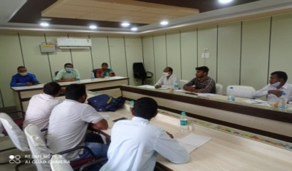
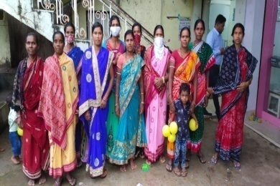
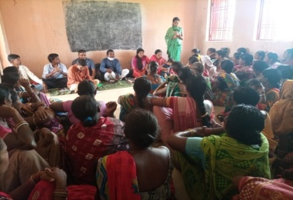
Domestic Violence and Adolescent Trafficking
Supported by Swiss League of Catholic women (SLCW)

This Program aimed to Combat Domestic Violence and trafficking was started on 2021. DAPTA Kalahandi implemented this program with the support from Swiss League of Catholic women (SLCW). Since the inception of the program 22 and 3 adolescent girls from Palsijharan GP and Kamthana GP who are working outside of the state have been tracked. Also 75 Nos. of DV cases from different GP of Kalahandi have been registered and the organization is spreading awareness massages against Domestic Violence. With the help of CHILDLINE, Kalahandi. DAPTA has stopped 13 nos. of Child Marriage cases. In addition, with the help of POLICE, CWC and CHILDLINE, Kalahandi, DAPTA has rescued 6 nos. of trafficking case in Kalahandi District. Under this program, DAPTA has provided counselling session and have solved some issues. To help the CHILDLINE 1098, Kalahandi, the organizing has facilitated to link 65 nos. of Children whose parent’s die during COVID -19 with ASHIRVAD SCHEME
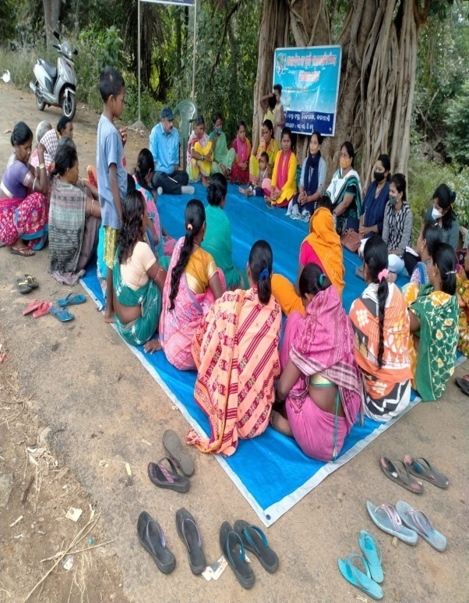 | 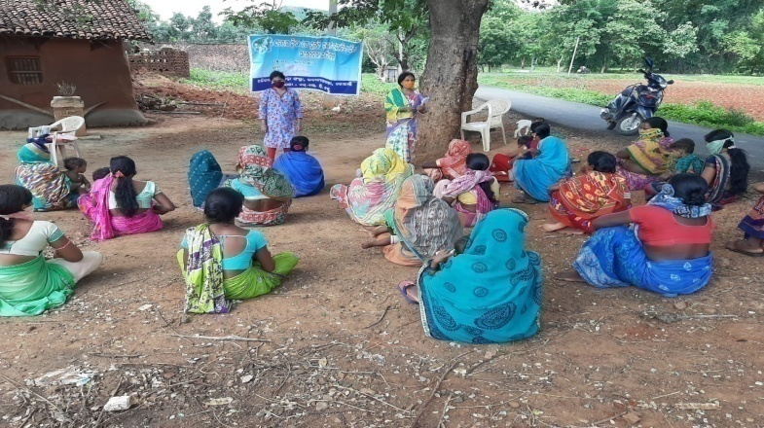
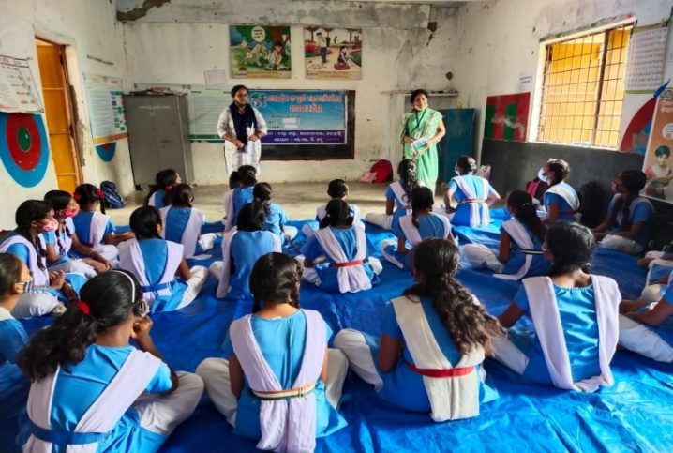 | 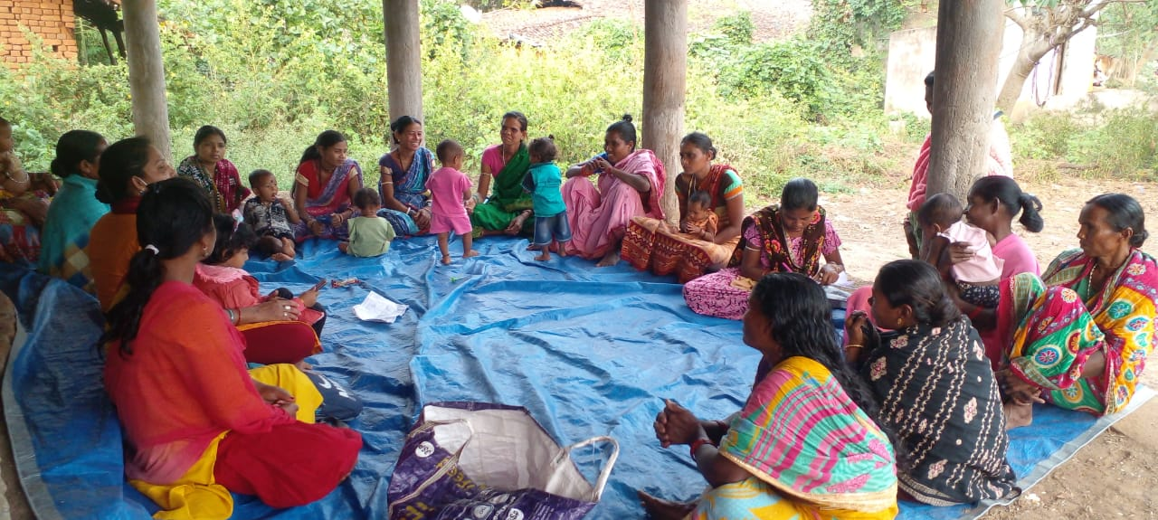
SL.NO | ACTIVITIES | NO. OF ACTIVITIES | PLACE | GRAM PANCHAYAT
1 | Adolescent Meeting | 165 | Bhangabari, Karlasoda, Borbhatta, Uditnarayanpur, Bailjor, Dumal, Ghumerguda, Badkhairmal, Kamthana, Palsijharan, Tentulichuan, Ghusrigudi, Dungipunga, Bhikajharan, Kholand | Kamthana Palsijharan
2 | Women Meeting | 165 | Bhangabari, Karlasoda, Borbhatta, Uditnarayanpur, Bailjor, Dumal, Ghumerguda, Badkhairmal, Kamthana, Palsijharan, Tentulichuan, Ghusrigudi, Dungipunga, Bhikajharan, Kholand | Kamthana Palsijharan
3 | Adolescent Training | 55 | Bhangabari, Karlasoda, Borbhatta, Uditnarayanpur, Bailjor, Dumal, Ghumerguda, Badkhairmal, Kamthana, Palsijharan, Tentulichuan, Ghusrigudi, Dungipunga, Bhikajharan, Kholand | Kamthana Palsijharan
4 | Women Training | 55 | Bhangabari, Karlasoda, Borbhatta, Uditnarayanpur, Bailjor, Dumal, Ghumerguda, Badkhairmal, Kamthana, Palsijharan, Tentulichuan, Ghusrigudi, Dungipunga, Bhikajharan, Kholand | Kamthana Palsijharan
5 | Thematic Training | 02 | Conference Hall, DAPTA, KALAHANDI | Bhawanipatna
6 | Coordination Meeting | 08 | Kamthana Panchayat Office  Palsijharan Panchayat Office | Kamthana Palsijharan
7 | Sensitization & Rally Programme for Women Group | 02 | Dumal village of Kamthana GP.  Palsijharan Panchayat Office Premises | Kamthana Palsijharan
8 | Sensitization & Rally Programme for Adolescent Girls group | 02 | Bhangabari Village of Kamthana GP.  Dungipunga Village of Palsijharan GP. | Kamthana  Palsijharan
9 | International Women’s Day | 01 | Palsijharan Panchayat Office Premises | Palsijharan
10 | World Health Day | 01 | Bhangabari Village of Kamthana GP | Kamthana
11 | Liasioning &Networking with CHILDLINE 1098 & Railway Police for Adolescent Girls | 01 | Dayanidhi High School | Kamthana
12 | Sadhvabana Diwas | 01 | Angnawadi Center of Badkhairmal Village | Kamthana
13 | Swachhata Abhiyan | 01 | Dumal Village | Kamthana
14 | National Panchayati Raj Diwas | 01 | Palsijharan Panchayat Office | Palsijharan

FCC (Family Counselling Centre)
Supported by Central Social Welfare Board
Covers Kalahandi District

With the aim to decrease atrocities, violence, harassment and family maladjustment, DAPTA provides preventive and rehabilitative services to women. DAPTA also create awareness on social issues affecting status of women. Thought the process of individual counselling, group counselling and home visit, DAPTA solved: 82 Cases. In 3 cases, DAPTA has taken the help of Police & One stop centre and have registered more cases in DLSA for Compensation.

In this respect DAPTA has conducted

- No of Awareness Camps/ Mohalla Meetings: 36
- No of Sub-Committee Meeting: 03

Type of Cases | No. of Cases Registered | No. of Cases Solved | No. of Cases Pending
Dowry | 10 | 4 | 6
Domestic Violence | 8 | 5 | 3
Alcoholism/Drug Addiction | 28 | 24 | 4
Marital Maladjustment Spouse & In-laws | 5 | 2 | 3
Economic Crisis | 8 | 8 | 0
Family & Property Dispute | 11 | 6 | 5
Extra Marital relationship | 22 | 12 | 10
Personality difference | 4 | 2 | 2
Mental & Physical torture | 26 | 14 | 12
Any other (Cheating & Parents Interference) | 7 (5 & 2) | 5 | 2
Total | 129 | 82 | 47

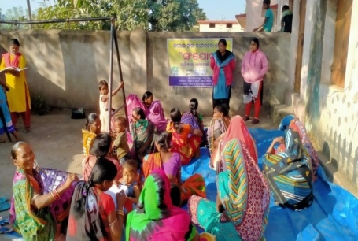 | 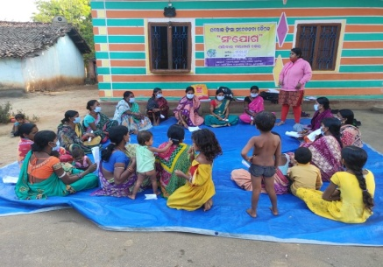 | 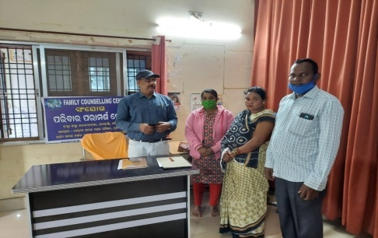
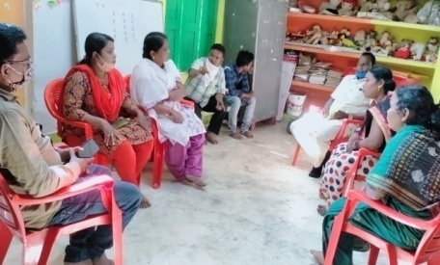 | 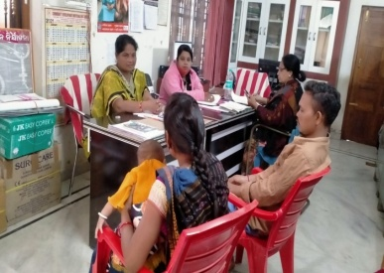 | 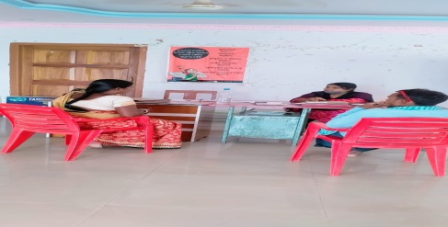
-: Project Shyamala: -
Livelihood Enhancement and Food Security
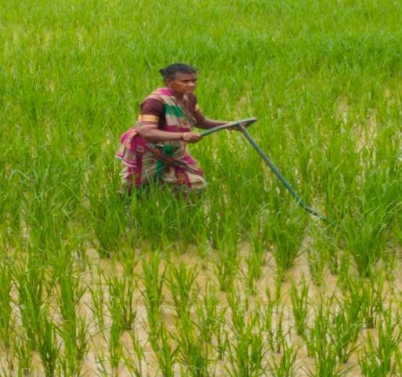
The overall objective of Livelihoods and Food Security interventions is to ensure sustainable food and economic security for populations vulnerable to political, socio- economic, climatic shocks. The main source of livelihood of the people of Kalahandi is agriculture. DAPTA is working in Bhawanipatna block of Kalahandi district to enhance the livelihood security of its targeted population. From the inception of DAPTA is working with small and marginal farmers to enhance their farm income and economic status.
DAPTA is working as one of the facilitating agencies in Special Program for Promotion of Millets in Tribal Areas of Odisha (Odisha Millets Mission). The organization has worked in 124 villages of 22 GPs in Bhawanipatna block of Kalahandi district in 2021-2022. DAPTA is helping to enhance productivity through improved practices and technologies; reducing the susceptibility of farming to shocks through climate-smart and environmentally sustainable approaches; improving business practices to make farming more profitable; facilitating links between producers, intermediaries, markets and last mile service providers; and, directly supporting firms and social enterprises to develop models and products appropriate for smallholder producers. In finance year 2021-2022, DAPTA reached out 1382 nos. of millet farmers and Total 3033 quintal of Ragi procurement from Millet farmers in Bhawanipatna block.
In nearly two-thirds of the world’s countries, women are more likely than men to suffer from food insecurity. At the same time, women are our most powerful allies in the fight against hunger. Hence, DAPTA give primary focus on women farmer and has organized women farmers through SHGs & Cooperatives and offering hand holding support by building their capacity and providing forward and backward linkages. The women farmers are doing commercial vegetable cultivation through an organic mode and are producing vegetables round the year. To upscale the knowledge and skill of farmers DAPTA organize periodical training program for the farmers besides on-site field level orientation.

Special Program for Promotion of Millet in Tribal Areas of Odisha
Supported by Millet Mission Govt. of Odisha

Odisha Millets Mission, a flagship programme of the Government of Odisha. Special Programme for Promotion of Millets in Tribal Areas of Odisha (Odisha Millets Mission) was launched by Govt of Odisha in 2017 to revive millets in farms and on plates. This comprehensive project includes campaigns for revivals of millets in household consumption, improving productivity of millet crop systems, promoting local processing enterprises and developing markets. It emerged from a consultation between Government, Academia (NCDS) and Civil Society Organisations (RRA Network, ASHA Network and local NGOs). It is first of its kind of agriculture programme with priority on increasing consumptions in Odisha.

To promote millets in its tribal areas is being implemented in Kalahandi district since Kharif 2017. DAPTA is working as one of the facilitating agencies from 1st January 2018. We have worked in 124 villages of 22 GPs in Bhawanipatna block of Kalahandi district in 2021-2022.

In the financial year 2021-2022, DAPTA reached out 1382 nos. of millet farmers and Total 3033 quintal of Ragi procurement from Millet farmers in Bhawanipatna block (KMS-2021-22). Against the targets of 750 hectares, DAPTA is able to bring 833.09 hectares under millet cultivation.
DAPTA has organized the following capacity building trainings &Activities

- 4 nos. of 2 Days Non-Residential Training on CRP & Progressive Farmers
- 2 Days Non-Residential Training within District for 10-member women campaign team.
- 24 Days Campaigns in villages to increase awareness on household consumption of millets (Millets Ratha).
- 3 nos. of 2 Days Block Level Training and Orientation of the CBO on community seed centre management.
- 4 nos. of 2 Days Non-Residential training of seed farmers organized at village level.
- 10 nos. of 2 Days Non-Residential Training of Trainers within district on System of Millet Intensification (SMI) organized.
- 10 nos. of Crop Cutting Camfield Day programme organized at field level.
- 3 nos. of 2 Days Training on Seed centre Management organised.
- 101 nos. of farmer’s meeting at village level for millets farmers selection and awareness meeting organized in different village of Bhawanipatna block.
- Non-Pesticides Management training to farmers for organic farming- We practically demonstrate on preparation of Bijamruta, Jivamruta&Handikhata in different villages. The millet farmers are actively participated in the programme. They also used or spraying it on Ragi Nursery bed & result also is very excellent. Many Ragi farmers are used the technique to his different crops also.
- Training and capacity build on Ragi Nursery bed raise.
- 2 hectors of seed production field prepared and farmer selection.
- Training on Ragi transplanting & weeding.
- Prepared Participatory Varietal Trail (PVT) field.
- Organized Procurement plan with Farmers Producer Company Ltd (FPO) &Tribal Development Cooperative Corporation of Odisha (TDCCOL)& monitoring the protocol.
- 2 Days Non-Residential Training of NGO staff, CRPS and Progressive Farmers on Mobile Application Documentation and Data Generation.
- 4 nos. of Community Seed Centre management.
- 4 nos. of Community Hiring centre management.
- Plan for installation of Ragi Processing Unit.
- Convergency and selected the SHG for Millet tiffin centre with ICDS& Odisha Livelihood mission.
- FPO- Dukuri Women Farmers Producer Company Ltd has registered with National Agriculture Market (eNAM) and NCDEX e-Markets Limited (NeML).
- FPO-DWFPCoL has received seed licence from Department of Agriculture & farmers Empowerment, Government of Odisha.
- FPO -DWFPCoL has signed MoU with TDCCoL, Kalahandi and CDAO cum PD-ATMA for empanelment as Procurement Agency during KMS-2021-22.

Supported to Millet Farmer and SHGs
- Incentive deposited to all 1382 millet farmers by PD ATMA under Odisha Millets Mission programme.
- Provide agricultural equipment through CHC centres those are- Cycle weeder, sprayer, plastic drum, tarpaulin under Odisha Millets Mission Programme.
- Provide 4 nos. of Ragi Thresher to 4 nos. of SHGs.
- Provide Solar powered ragi processing unit to WFPO with the support of SELCO Foundation.
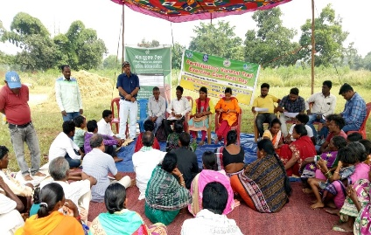
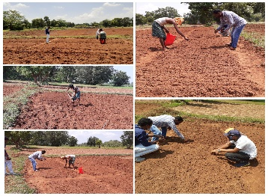
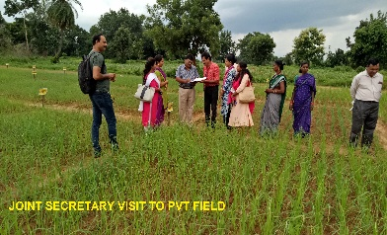

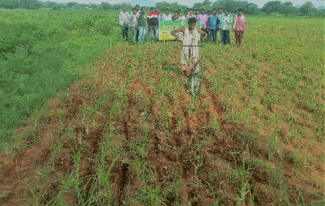
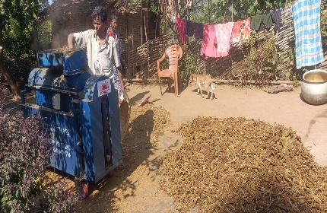
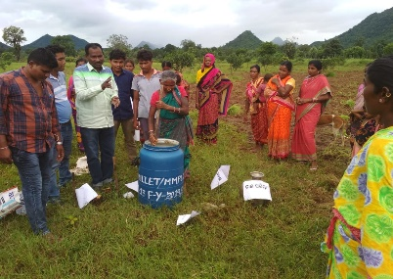

Women in Agriculture
(Strengthening women’s Vegetable Grower Cooperatives, Women’s Farmers Producer Company, LEDP, Rural Mart)

Agriculture is an important component of rural livelihoods. Women play a pivotal role in all agricultural operations from planting-to-harvesting-to-post-harvest operations. Recently government of India has given high priority on ‘Recognition and Mainstreaming of Women’s role in Agriculture ‘through incorporation of ‘pro-women initiatives’ in various Schemes / Program / Missions and earmarking of at least 30% of benefits and resources for women under all such beneficiary-oriented interventions. The FAO reports that abolishing gender-specific barriers in farming, would not only empower women to achieve their highest economic potential, it could help feed a hungry world.
DAPTA has implemented various pro-women program to bring women fore-front in the agricultural sector.
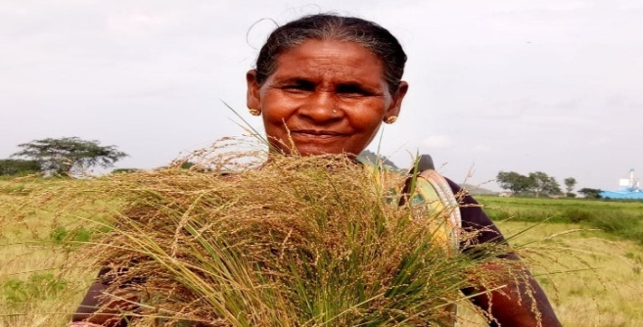 | 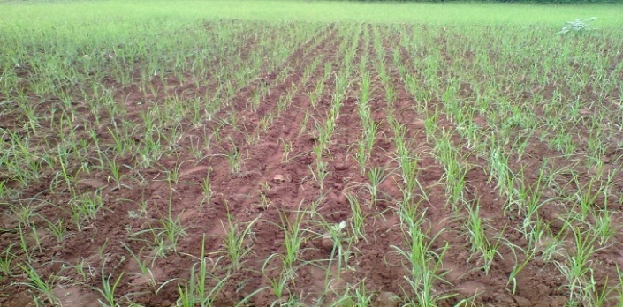
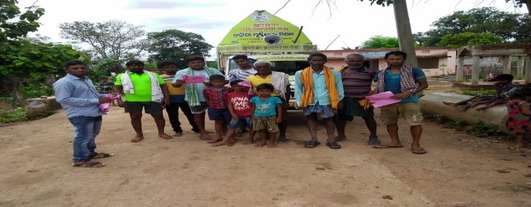 | 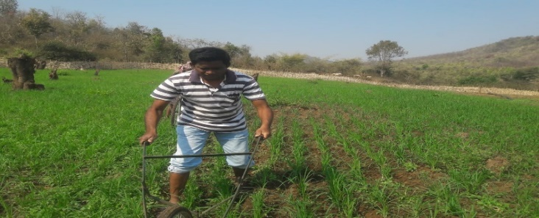

Strengthening Women’s Vegetable Grower Cooperatives
Supported by AWO International and NRLM

Witnessing DAPTAs long intervention with SHG and their vegetable cultivation, DAPTA selected few SHG and provided technical input and support in vegetable cultivation in cluster basis in the year 2010. In this effort a big change came to notice, involvement of Women farmers in Agriculture. Many a women farmers came forward for vegetable cultivation with the support of DAPTA in the year 2010 with the support of AWO international. DAPTA facilitated to form and strengthen 2 nos. of Women farmers Vegetable growers Cooperative in the year 2010 and later on formed and strengthened another 2 nos. of Women farmer Producer Cooperative in the Mahila Kissan Sashakti Karana Pariyojana Program. Now all producer cooperatives are working smoothly and they have set up their own weekly market to sale their products.
SI NO | Name of Women farmer cooperative | Total Member | Share Capital | Registration date and no | Total Fund
1. | Maa Lankeswari Pariba Utpadanakari Samabaya Samiti Ltd | 311 | 25200/- | 472/ARCS/BPT/CS  21/112016 | 85434/-
2. | Mahalaxmi Pariba Utpadanakari Samabaya Samiti Ltd | 260 | 21,900/- | 06/DRCS/KLD/CS  06/09/2016 | 6,11,978/-
3. | Maa Tarini Pariba Utpadanakari Samabaya Samiti Ltd | 302 | 16600/- | 474/BPT/CS  31/12/2018 | 23986/-
4. | Maa Manikeswari Pariba Utpadanakari Samabaya Samiti Ltd | 265 | 26,500/- | 07/DRCS/KLD/CS  05/09/2013 | 6,80,013/-
Women’s Farmers Producer Company
Supported by NABARD

As livelihood is a main focus of our objective, DAPTA is working from very beginning to enhance livelihood standard of poor and marginal farmers through many a farm and off farm base activities. DAPTA promotes women farmers those really struggle to enhance their income. Basing on the ground reality, DAPTA has facilitated to form and strengthen 2 nos. of Women Farmer producer company WFPC those are doing vegetable production, value addition, marketing. One of the companies is engage in millet promotion, value addition and marketing activities. Both the Women farmer’s company are own managed having clear concept. They have prepared their business development plan to go ahead. Now leadership quality and business technique has developed with them and DAPTA is providing hand holding support to gear up.
One of the Women Farmer companies has awarded 2 nos. of Agriculture Project by competing tender process with Agriculture Dept. Govt. of Odisha.

Sl. No | Company Name | Registration Number | Total Member | Total Share capital | Total Turnover
1. | Mati Putra WFPCL management by DAPTA Kalahandi | U01114OR2018PTC029581 | 501 | 52100/- | 3500000/-
2. | DUKURI WOMEN FARMER’S PRODUCER COMPANY LIMITED. | U01100OR2018PTC029638 | 502 | 501000/- | 4823400/-
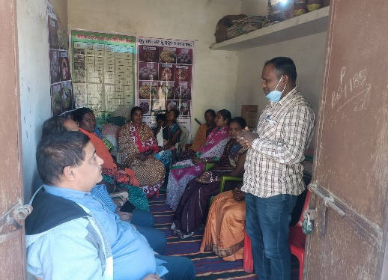
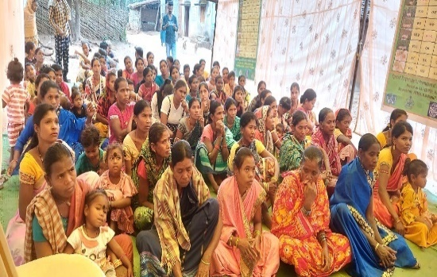
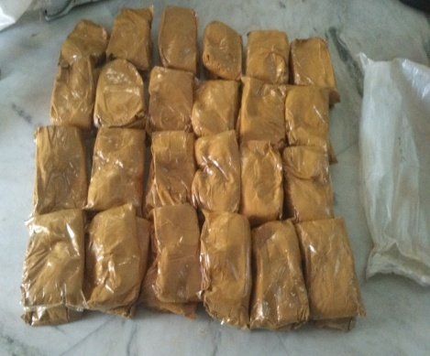
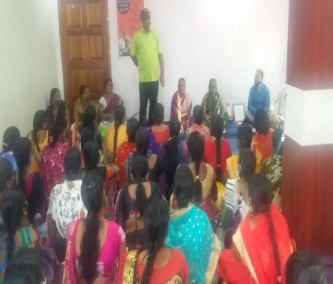
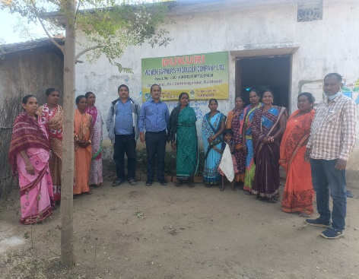

LEDP TRAINING
Supported by NABARD

Introduction
During 2014 DAPTA has started its activities at Tileibani Block with community led Sanitation program. Then DAPTA came in touch with SHG and Women farmers of the Locality.
After discussing with Women farmers and their opinion that technical training on vegetable and Mushroom cultivation can increase their household income, DAPTA submitted proposal to NABARD which got sanctioned and the program started from 1st October,2019 and due to corona, the project ended in little late. In this training, we provided training to 90 women farmers on Vegetable Cultivation and 30 Women farmers on Mushroom Cultivation with need base demonstration.
Objective of the project
The objective of the project was to increase house hold income of Women farmers through farm base activities.
Another objective was to facilitate Women farmers to link with financial institution, market and convergency link with different line department.
The overall objective is to strengthen income generation of Women farmers those will be able to lead a meaningful life.
Methodology of the project
The methodology was to provide in house training to farmers in two phase like phase one and refresher training of 2 days in the mid intervention. Besides that, training will follow by a need base demonstration. Handholding support will be provided to SHG for bank linkage.
Expected Deliverables of the project
  - -The Deliverables of the Project was to Provide training to 120 Women farmers.
  - -90 farmers will be trained on different Vegetable cultivation.
  - -30 farmers will be trained on mushroom cultivation.
  - Farmers will link with financial institution and their income will be enhance.
- Implementation Process
  - Identification of potential beneficiary

  - Social mobilization and Village level meeting

  - Demonstration unit.

Conduct of Skill development and Training program (type of training program, involvement of institutes of repute or Govt, line departments, trainer details in brief)
  - Strengthening of WSHGs

  - Credit linkages with banks
- Monitoring and Hand holding support

- Convergence with Line Departments

- Outcome of the project
90 Women farmers trained on vegetable cultivation
30 Women farmers trained on Mushroom Cultivation.
All 120 Women farmers are practicing in field and their income has enhanced.
All are linked with Bank through their respective SHG.
50% income has enhanced from their earlier income.
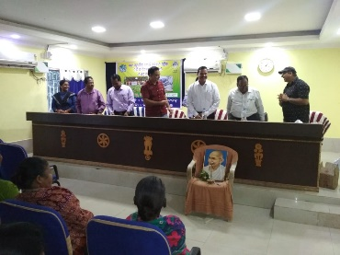
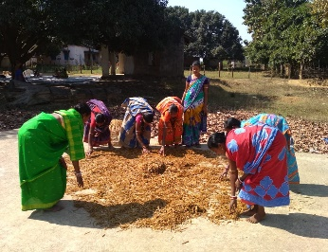
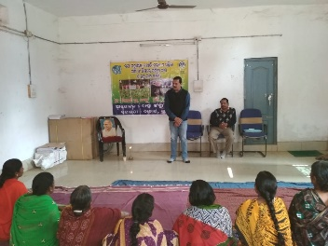
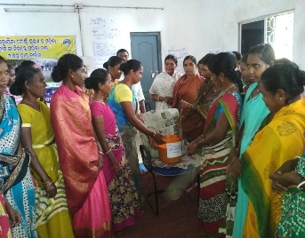

RURAL MART
Supported by NABARD

BRIEF REPORT OF RURAL MART
Name of the FPO- Matiputra Women Farmer’s Producer Company Limited
Facilitating Agency - DAPTA Kalahandi.
Support by – NABARD, Bhubaneswar

- Project title: Setting up of Marketing Outlet at Bhawanipatna, Kalahandi.
• Project Area: G.P.- Medinipur and Gudialipadar Block- Bhawanipatna Dist.- Kalahandi.
• Details of beneficiaries: 501 no’s of Small & Marginal Women Farmer’s.
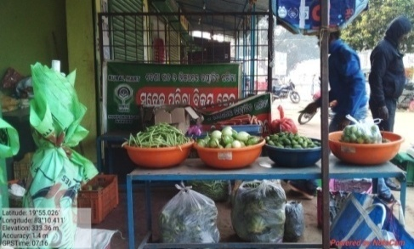
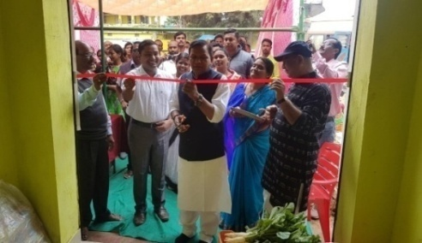
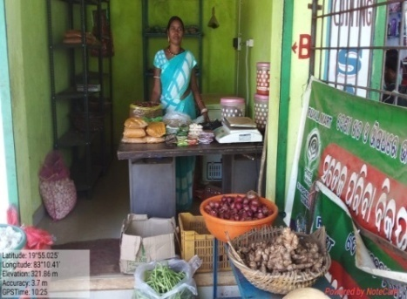
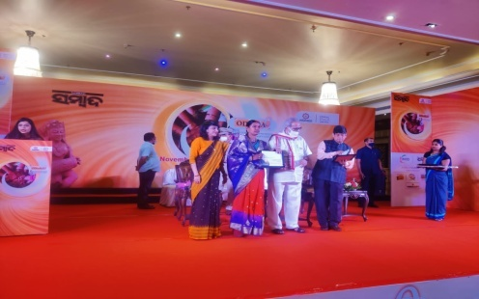
• Brief Introduction of project: In the year 32 no. of SHGs came together and formed a farmer producer company named Matiputra Women Farmer Producer Company Limited (MWFPCL). Initially the total membership was 250 in the initial period which increase later on. Now there are 501 women farmers in the company. Most of them are vegetable producers and they used to produce vegetables round the year. Marketing was one of the biggest issues for them. Since it is a perishable item sometimes Bhawanipatna manage a Rural Mart. Sometimes the loss becomes unbearable for the farmers. There is no such provision either by government or any private agency for proper storage of the produces/ vegetables. Bhawanipatna is the nearest market place about 12 km. Since marketing was the major challenge most of the time the members was struggling to get out of the challenge. Finally on dt. 10.09.2019 it was decided to approach NABARD to support the company in order to market their produces in Bhawanipatna. On dt.20.11.2019 NABARD supported the Rural Mart to MWFPCL and was inaugurated on dt. 06.02.2020 by the MLA Bhawanipatna and leader of opposition Mr. Pradipta Naik in the presence of DDM NABARD Malaya Kumar Meher and the same Rural Mart outlet is continuing now. The Matiputra Women Farmer Company has awarded SHARADA SEEMA SAMMAN in Odisha by the Governor of Odisha.
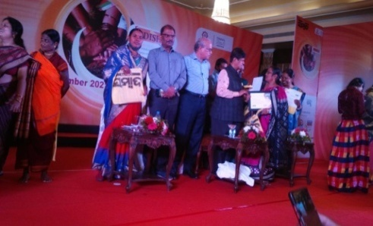

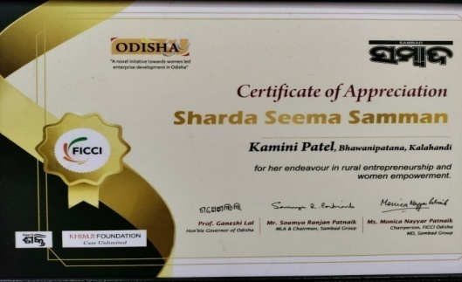
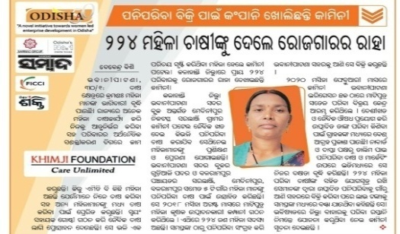

Bee Keeping
Supported by Barefoot College International, Tilonia

ENRICHE Beekeeping, as a Livelihood skill for rural women in the state of Odisha, was implemented by DAPTA in the year 2021with the support from Barefoot collage International, Tilonia. The project covers Bhawanipatna block and Lanjigarh block of Kalahandi district. DAPTA has selected 30 number beneficiaries, which includes 14 number beneficiaries from Gudialipadar G.P, Bhawanipatna block and 16 number of beneficiaries from Lanjigarh block of Kalahandi district.
DAPTA has identified 30 women from marginal farmer group. These beneficiaries are trained on beekeeping by Dr Bikash Patra where they learnt about bee’s role in the environment, maintain the bee colonies, extract of honey and sale the raw honey at a fair price. Barefoot College, Tilonia is facilitating as a central hut for the logistic processing and marketing of the honey. These women can sell this honey in the market at a fair price.
Bee keeping will add income to the beneficiaries. The main Resource person of this initiative Dr Bikash Patra is closely supporting beneficiaries by providing timely guidance and suggestions. This year beneficiaries have started honey collection and collected 1 to 2 liters. per box.
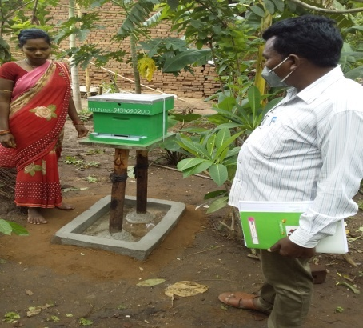 | 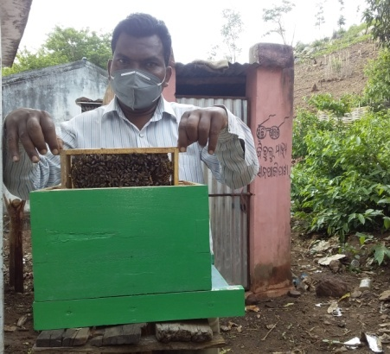 | 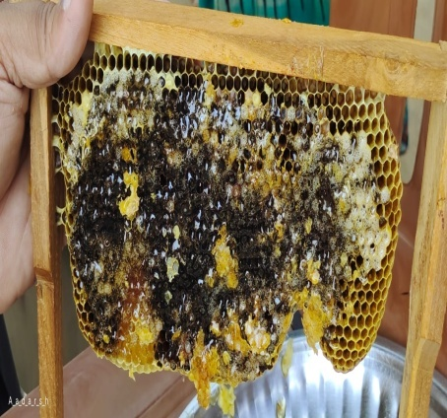
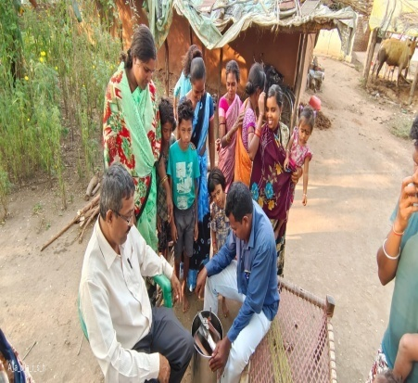 | 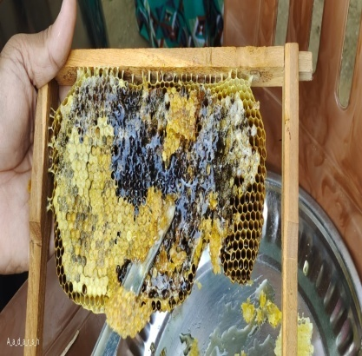 | 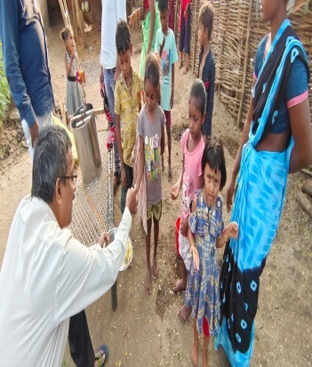

-: Project Swasthya: -
(Health for All)



According to WHO, "'Health for All' does not mean an end to disease and disability, or that doctors and nurses will care for everyone. It means that resources for health are evenly distribute and that essential health care is accessible to everyone. It means that
health begins at home, in schools, and at the workplace, and that people use better approaches for preventing illness and alleviating unavoidable disease and disability”.
The community health initiatives remain one of the DAPTA’s flagship service in order to make people to lead a healthy life with dignity. Community Mental Health care and HIV/AIDS prevention and care remained the focus the organization during this year. DAPTA, with the support from Odisha State Aids Control Society (OSACS) has implemented the targeted intervention project in Bhawanipatna, Lanjigarh, Junagarh & Jaipatna Block of Kalahandi district. In the year 2021-22, DAPTA have covered 372 beneficiaries, out of them 215 are MSM &157 are TG. DAPTA has organized Demand generation meetings in different hotspot and conducted Health camps. To increase awareness and knowledge about HIV/AIDS, ways of transmission, and ways of preventing transmission among the selected groups, DAPTA has celebrated world AIDS day, conducted awareness program and promotional activities, through appropriate advocacy.

Mother & Child Health Care
(Promoting Community Health, Education & Access to Government Health Services among PVTGs of Lanjigarh Block of Kalahandi district of Odisha)
Supported by Azim Premji Foundation

“The Community Health Education and Empowerment” Initiative for Vulnerable Tribes (PVTG) of Kalahandi with the support of Azim Premji Foundation (APF) started from 1st April 2020 in 80 PVTG villages in Lanjigarh.
Objective –
To improve the quality of life of the people of the targeted community by improving the health & Education status and increasing access to Government schemes provision and services.
STRATEGIES

Strategy | Activity | Output Produced
- To provide community-based Primary Health Care services to the targeted PVTG community. | Village Health Centre
 | General OPD Service | - 5330 patients received treatment in 250 General OPD days.
 | Special OPD Service | - 31 special OPDs (Under 5, Pregnant women & Chronic patient) carried out during the reporting period where 330 patients diagnosed and treated.
 | Community Outreach Health Camps | - 52 Community outreach health camps conducted where 2116 patients from about 50 villages received treatment.
 | Malaria Control and Management | - 2265 fever cases tested malaria (Health camp & OPD) and 981 found malaria positive and received complete treatment.
 | Maternity Waiting Home for High-risk Pregnant women | - 35 High risk pregnancies received needed services from the maternity waiting home
 | Active Referral for secondary and tertiary treatment | - 204 patients actively referred from the OPDs, health camps & by village Swasthya Sathis to the DHH and above and received secondary and tertiary treatment and care.
 | Active Growth Monitoring of under 5 children | - 1500 under 5 children undergone periodical active growth monitoring at the village level.
 | Early identification of SAM children | - 16 SAM (Severe Acute Malnourished) children identified at the early stage during growth monitoring and got admitted into NRC (Nutrition Rehabilitation Centre), Bhawanipatna
 | Village Level Recipe Demonstration (Local and Focal) | - Recipe demonstration conducted in all 80 villages to promote local nutritious recipe for children.
- To promote quality primary education and ensure grade appropriate learning through special education centers and adding value in existing schools | Village Education Centre | - 4 nos. of village education centers established and became operational from the month of June in 4 remote PVTG villages with 120 children @30 children per 1 center.
 | Regular classes in Village Education Centre | - Regular classes conducted for 204 days during the reporting period.
 | Food & Nutrition for students | - Children received MDM for 204 days
 |  | - School Uniform, School Shoe, School Bag, Learning & playing materials provided to all 120 children.
 | Parents Committee Meeting | - Parents committee meeting organized 4 times in order to enhance the participation and ownership of the targeted community.
 | Training of teachers | - Training organized for the teachers of the village learning centers twice during the reporting period in order to capacitate them to build the center child friendly and impart education in a joyful manner.
- To enhance the coordination and support building of the community with PRI members, opinion leaders, youth, SHG leaders and front-line service providers to empower & create an enabling environment for delivery of services with increased ownership and accountability | Village heath leaders (Swasthya Sathis) capacity building | - 40 Community Health Leaders (Swasthya Sathis) received training on leadership and community mobilization.
 | Formation and strengthening of Mothers Committee | - Mothers Committee formed in all targeted 80 villages and meetings organized on women and health issues to prepare them to take over their issues on their hands.
 | GP level Quarterly Stakeholders Meeting | - 15 nos. of GP level quarterly stakeholders meeting organized to increase the community ownership and participation in the local healthy governance. PRI members, SHG leaders, youth leaders, opinion leaders and service providers participated.
 | Half yearly planning and review meeting with health service providers | - 09 nos. of GP level Half yearly service provider meetings organized to initiate convergent action to address the health issues and to shoot out the emerging issues and to strengthen the support and coordination among govt. service providers, NGOs and community health leaders.
 | Piggy bank to promote institutional delivery | - 126 pregnant women from the hard-to-reach villages received piggy bank to manage the incidental expenditure during hospitalization for delivery. (An innovative initiative to promote institutional delivery in the remote tribal villages. (An earthen piggy bank is given to the pregnant women where her name and expected date of delivery is written and she is continuously motivated and persuaded to save as much as she can and to break the piggy bank getting delivery pain and keep the total savings in her hand before going hospitals for institutional delivery).
 | Trained Birth Attendants (TBA) training Programme | - 11 nos. of TBAs (Trained Birth Attendants) selected and trained from the remote and inaccessible villages (where home deliveries are more) to ensure clean and safe delivery
 | Staff capacity building | - Thematic training organized for the project staff to increase their capacity in order to deliver the deliverables effectively and efficiently.
 | Quarterly meeting for Block level support & Monitoring committee meeting. | - The block level support and monitoring committee organized to disseminate and share the achievements against the target and also for the emerged trouble shooting. Medical officer, BPM NHM, PHEO, ANMs and project staff remain present and participated actively.
 | Community Health MIS | - Community health MIS initiated and updated in all targeted 80 villages.

Active Referral Recipe Demonstration
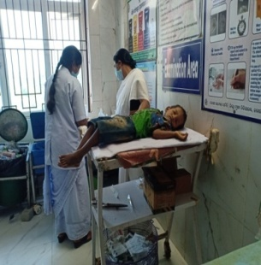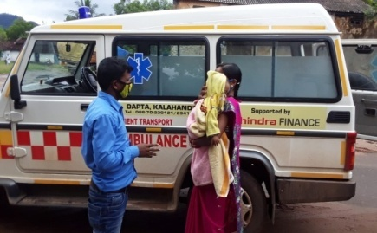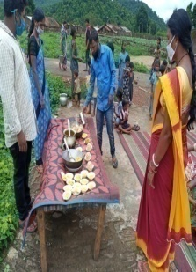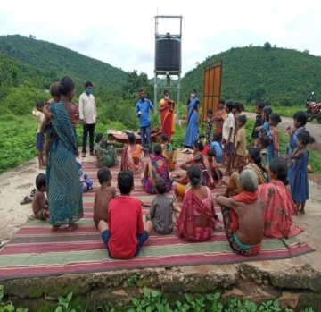
Stakeholders Meeting Community Meetings & Mothers Committee Meetings

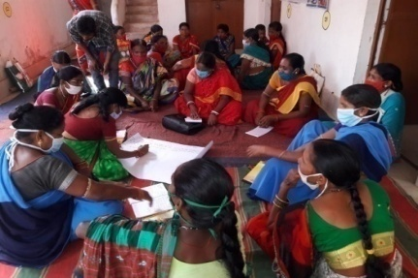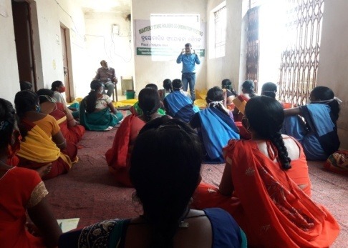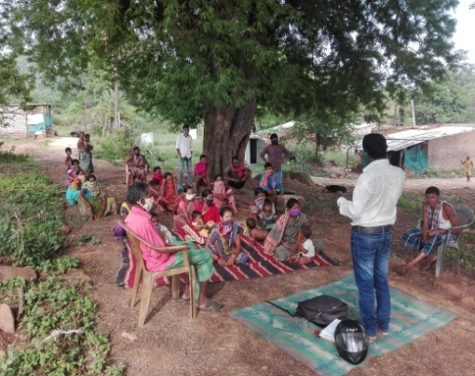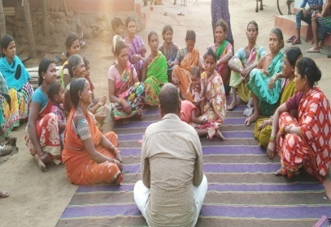
Outreach Health Camps & Community Clinic
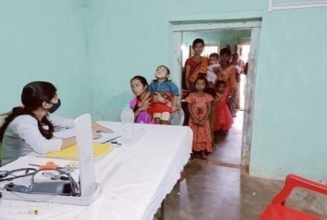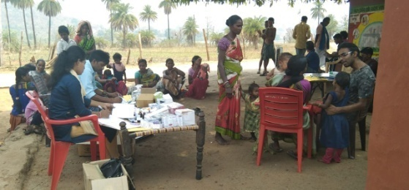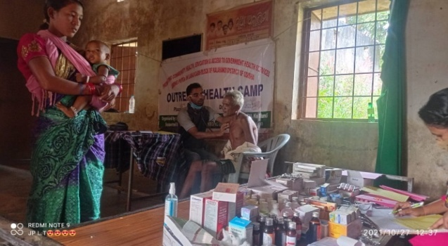
School Health Education Programme
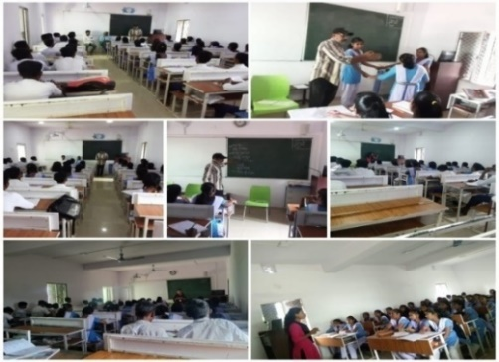

Targeted Intervention Project (T.I, project)
Supported by Odisha State Aids Control Society (OSACS)

DAPTA, with the support from Odisha State Aids Control Society (OSACS) has implemented the targeted intervention project in Bhawanipatna, Lanjigarh, Junagarh & Jaipatna Block of Kalahandi district. In the year 2021-22, DAPTA have covered 372 beneficiaries, out of them 215 are MSM &157 are TG.

The objectives of this program are

- To prevent infections through saturation of coverage of high-risk group with Targeted Intervention scaled up intervention in a general population.
- To provide greater Care, Support & Treatment to larger number of PLHAs (60%).
- To strengthen the infrastructure system and human resources in Prevention, Care & Support program at District, state and National level.
- Increasing awareness and knowledge about HIV/AIDS, ways of transmission, and ways of preventing transmission among the selected groups.
- Increasing knowledge about CONDOM and its use by the target groups. Increase knowledge about the signs and symptoms of STIs and increase appropriate treatment seeking for STIs.
- Make the environment more conducive for carrying out HIV/AIDS related awareness and promotional activities, through appropriate advocacy.
Sl. No. | Activity | Target | Achievement | Percentage
1 | One to One Contact | 4896 | 4479 | 91%
2 | Regular Contact | 4896 | 4384 | 89%
3 | Condom Demand VS. Distribution | 137940 | 131762 | 95%
4 | No. of HRGs counseled | 1600 | 1596 | 99%
5 | No. of HRGs refer to ICTC | 800 | 704 | 88%
6 | No. of HRGs tested at ICTC | 800 | 704 | 88%
7 | No. of HRGs tested at Network Clinic | 1600 | 1333 | 84%
8 | Regular Medical Check up | 1600 | 1214 | 76%
9 | STI | NA | 46
10 | Presumptive Treatment | 60 | 60 | 100%
11 | No. of HRGs tested at RNTCP | NA | 63

Activities | Outputs
Demand Generation Activity | We have organized 40 no. of Demand generation meeting at our different hotspot. The objective behind the activity is to increase HIV/TB testing, protective sex. We also discussed on signs and symptoms of HIV/AIDS, STI/STD, uses and benefit of ART medicine & safe behavioral practices. During the year we covered398 key populations through the hotspot meetings. 60 no of new HRG (key population) identified during the meetings.
Health Camp | We conducted 2 nos. of Health camp at Bhawanipatna and Jaipatna operational area. In this camp we covered 60 nos. of HRGs and checked up their health status by a Doctor and provide medicine as per their disease. We also organized a small awareness meeting on their personal hygiene, healthy life and advise them on HIV/AIDS, STD/STI and safe sex.
World AIDS Day | On the eve of World AIDS day, we the DAPTA TI observed World AIDS say week from 25/11/2021 to 1/12/2021 at the different hotspot of our operational area with our HRGs. During these days we spread the message of Global Solidarity & Shared Responsibility near of the HRGs and others. Through various events, small group meetings and one to one contact our PE, ORWs were trying to aware the people on HIV/AIDS & spread the message of global solidarity, shared responsibility.
Advocacy Meeting | This year we conducted 3 nos. of Advocacy Meeting with different service providers of our project area. Objective of this meeting was to initiate the HIV testing of Key Population, linkage them to social scheme and give social justice in their day today life. It was decided to have proper coordination and mutual understanding with all service providers.
Community Event | On 21th December 2021 TI Project DAPTA organized a community event for creating awareness among the Key population at Jaipatna Site. In this occasion we organized a small group meeting where we gave brief knowledge on various topics.  - Why TI project is working for MSM/TG community.  - Component of TI.  - About HIV/AIDS  - About PLHIV & their treatment  - Condom Promotion  - Social security scheme
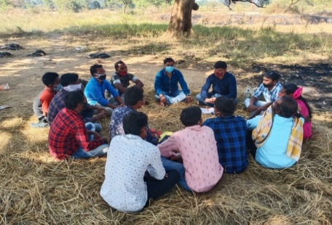  Demand Generation Meeting | 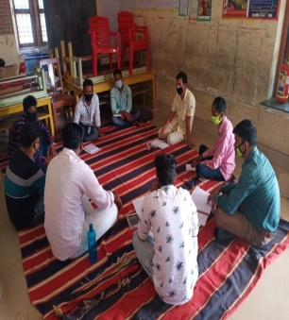  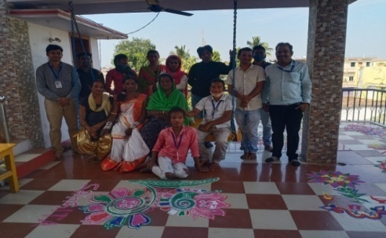  Celebration of World AIDS day | Staff Review Meeting
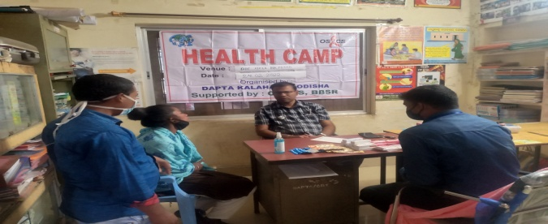  Health Camp | 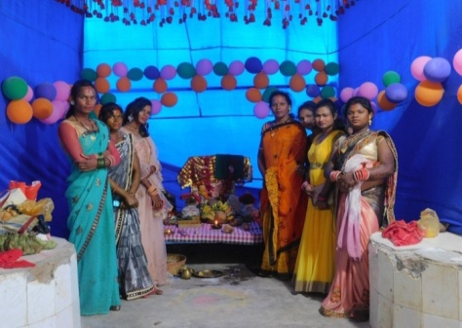  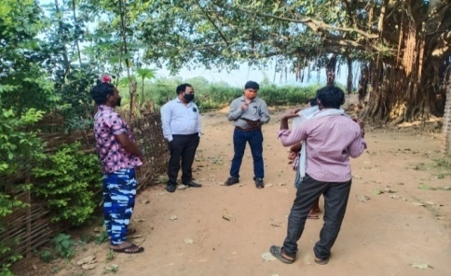  Field visit  Field Visit | Community Event
SWEEKRUTI
Supported by SSEPD

Supported by JIV DAYA FOUNDATION

The project Sweekruti supported by SSEPD department, Govt. of Odisha is meant for livelihood promotion of transgender community of Odisha. The SSEPD dept. has given responsibility to DAPTA to work in Kalahandi, Nuapada, Nabarangaur of Odisha with transgender community. This year DAPTA has implemented following activities for promotion of livelihood with transgender community.
Skill Up-gradation Training Programme-
Sl No | Date | Place | Participant | Topic | Outcome
1 | 4.2.2022  to  10.2.2022 | Sri Lingaraj Hotel, Tentulikhunti  Nabarangapur | 7 nos. | Mushroom Cultivation | To mainstreaming the transgender into the society and enable them to start income generating activity DAPTA Organized a seven days Skill development at Sri Lingaraj Hotel, Tentulikhunti on mushroom cultivation with 7 number of Transgender. Resource persons Gajendra Das & Pradeep Jani provide the training to the Transgender on mushroom cultivation. Mushroom is a commercial crop. In Odisha mostly paddy straw mushroom and oyster mushroom are cultivated. The main aim of training on mushroom cultivation was to facilitate the complete knowledge of mushroom production activity on commercial scale.  The broad Objectives of Mushroom Cultivation  .Characteristics of mushroom  .Importance of mushroom cultivation  .Procedure  .Climatic requirement  .Materials required  .Practical Demonstration  .Marketing and Value Chain
2 | 11.2.2022  to  17.2.2022 | IYSARA Organization Conferrence hall,Nabarangapur | 6 nos. | Mushroom Cultivation | To mainstreaming the transgender into the society and enable them to start income generating activity DAPTA Organized a sIX days Skill development at IYSARA conferrence hall, Nabarangapur on mushroom cultivation with 7 number of Transgender. Resource persons Gajendra Das & Pradeep Jani provide the training to the Transgender on mushroom cultivation.Mushroom is a commercial crop. In Odisha mostly paddy straw mushroom and oyster mushroom are cultivated. The main aim of training on mushroom cultivation was to facilitate the complete knowledge of mushroom production activity on commercial scale.  The broad Objectives of Mushroom Cultivation  .Characteristics of mushroom  .Importance of mushroom cultivation  .Procedure  .Climatic requirement  .Materials required  .Practical Demonstration  .Marketing and Value Chain
3 | 11.03.2022  to  20.03.2022 | DRTC training hall, Bhawanipatna  Kalahandi | 10 nos. | Goatary Farming  &  Mushroom Cultivation | To mainstreaming the transgender into the society and enable them to start income generating activity DAPTA Organized 10 days Skill development training programme in Kalahandi district. 10 nos. of transgender were participated in this training programme. Dr. Ashok Kumar Panda and Mr. Umakanta Mohanty joined as a resource person and they gave the training to the Transgender on Goatary farming & Mushroom Cultivation respectively.  The broad Objectives of Goatary farming  .Goat value chain & major issues in rural goat faeming & remedial measures.  .Selection of goats and accommodation.  .Modern practices in goat farming.  .feeding management.  .Credit linkage, Insurance.  .Entrepreneurship skills.  .Marketing.

Photo Gallery
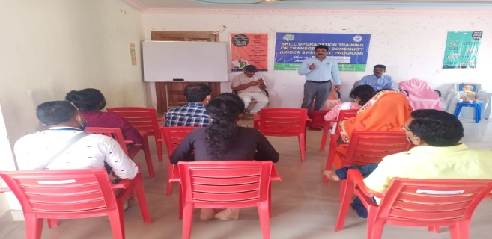
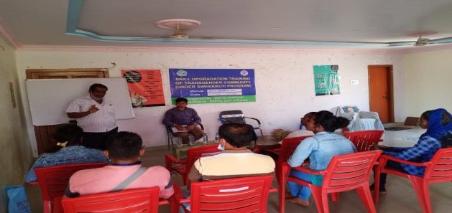
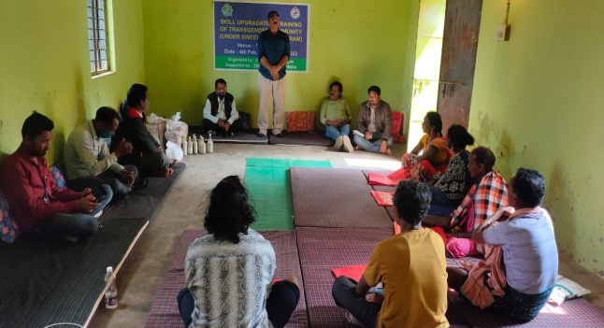
DISABILITY SUPPORT
Supported by JIV DAYA FOUNDATION

This year DAPTA has completed a survey of Physically challenged people of Lanjigarh Block. We found 95 people those are in need of disability aid to smoothen their life. Basing on the study, DAPTA submitted a proposal to Jiv Daya Foundation for possible support. After a scrutiny JDF, Dallas supported to 17 beneficiaries of Lanjigarh Block with wheel chair and tri cycle. In one program, DAPTA handed over all mobility aid and equipment in the presence of MP Kalahandi and BDO Lanjigarh.
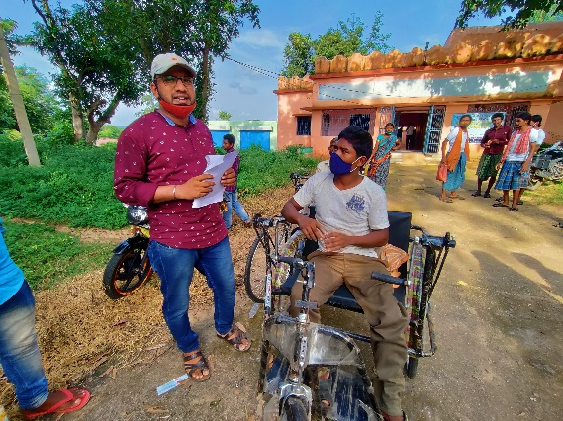
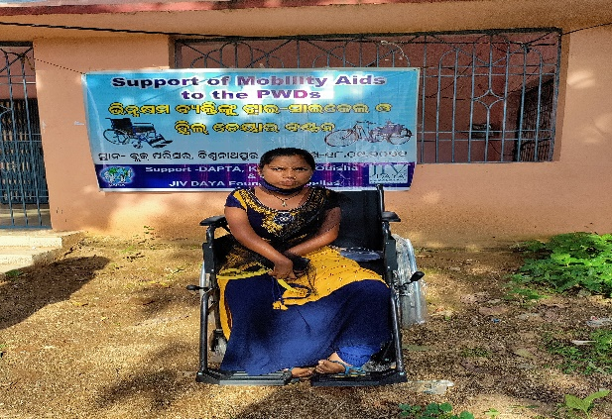

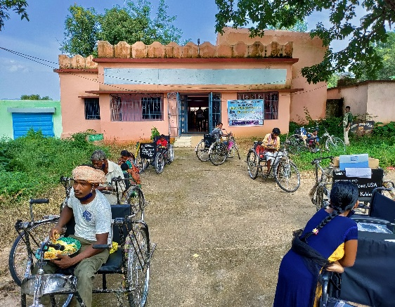
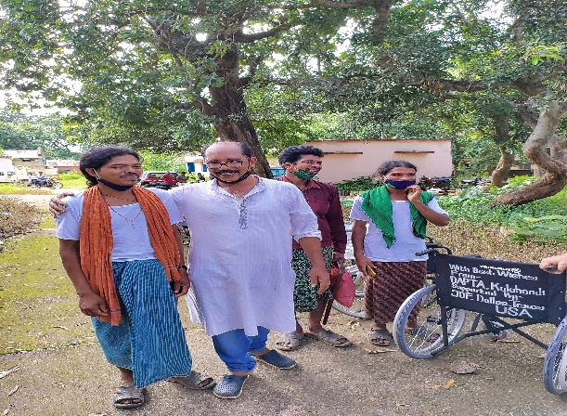

-: Project Surakhya: -
(Education, Child Right and Child Protection)



The parliament of India enacted the Right of Children to Free and Compulsory Education Act or Right to Education Act (RTE) on August 2009. The same got enforced on April 1st 2010.As per the act, education is a fundamental right of every child who is between 6 and 14 years old. The act also states that until the completion of elementary education, no child shall be held back, expelled or required to pass a board examination. There is also a provision for special training of school drop-outs to bring them up to par with students of the same age. According to the Integrated Child Protection Scheme (ICPS) Child Protection is about keeping children safe from a risk or perceived risk to their lives or childhood. It is about recognizing that children are vulnerable and hence reducing their vulnerability by protecting them from harm and harmful situations.
DAPTA, has implemented education Project in out of reach areas with PVTG community vulnerable children with the support of Smile foundation and Azim Premji Foundation. Also, DAPTA is working on Child Protection and right CHILDLINE services are provided by DAPTA. The organization aims to reach out to every child in need and ensure their rights and protection.

Mission Education Project
Supported by Smile Foundation & Azim Premji Foundation

School is the foremost fountain of knowledge children are exposed to. It gives a chance for them to acquire knowledge on various fields of education. The Parliament of India enacted the Right to Education Act 2009 to grapple with the downward spiral of the education system and poor learning outcomes. The act aims towards providing free and compulsory elementary education to kids between the age group of 6 years to 14 years.

DAPTA, with the support from Smile Foundation of India has implemented Mission Education Program in 3 number of villages like Kanarla, Sorpadar and Dahani padar while Azim Premji Foundation has supported 4 numbers of centers in remote villages like Karlijodi, Karkamaska, Kulanal and Fuldumer of Lanjigarh Block. All villages are remote in nature and there is no scope for children to approach a school. The major Objectives are as follows.
Provide education to deprived children.
- . Ensure grade appropriate learning level.
- . Enhanced enrolment into primary education
- . Mainstreaming to formal education
- . Ensure quality education
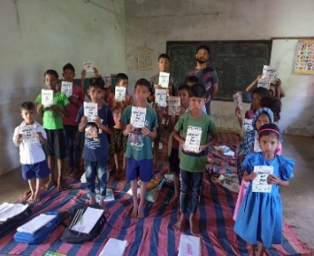
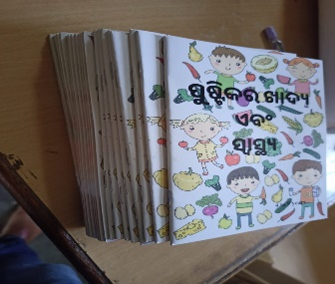
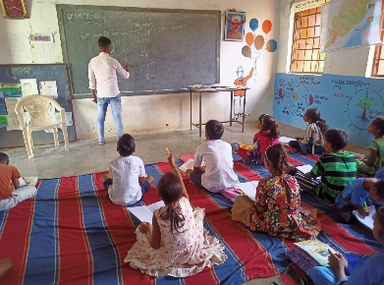
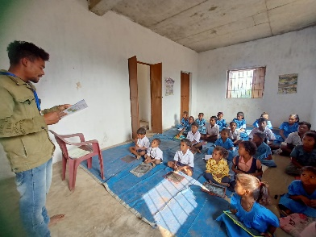
Description of Activity | Unit | 1st Half Year  2021-22 |  | 2nd Half Year  2021-22 |  | Grand Total
Description of Activity | Unit | Plan | Achieved | Plan | Achieved | Plan | Achieved
7 Education centers are running in cluster of villages from where children from excluded community are able to come school. Selected teachers from PVTG community will provide  appropriate teaching to children | Number of Education Centers | 7 | 7 | 7 | 7 | 7 | 7
Kui-speaking teachers from the community will be hired and trained for teaching children | Number of Teachers hired | 7 | 7 | 7 | 7 | 7 | 7
Regular classes will be held for children aged 6  to 9 years for 26 days in a month | Number of working  days of the school | 156 | 66 | 156 | 138 | 312 | 204
Provision of Food & Nutrition for students | Number of students | 180 | 120 | 0 | 120 | 180 | 240

CHILDLINE Service, Kalahandi
Supported by CHILDLINE India Foundation

CHILDLINE started at Kalahandi on 15th of December 2018. 1098 is a free emergency phone service for children in need of aid and assistance.

DAPTA have not only responded to the emergency needs of children but also linked them to relevant services for their long-term care and rehabilitation.
Vision - A Child-Friendly nation that guarantees the rights and protection of all CHILDREN.
Mission- CHILDLINE aims to reach out to every child in need and ensure their rights and protection.

CHILDLINE Report For the period of 21st April 2021 to March 2022
Month | Case Intervention | Community Meetings | SHG Meeting | Phone Testing | Monthly Meeting | Weekly Meeting | School sensitization | Open house
April 2021 | 7 | 2 | 2 | 63 | 1 | 2 | 0 | 0
May 2021 | 39 | 0 | 0 | 0 | 1 | 0 | 0 | 0
June 2021 | 37 | 1 | 0 | 72 | 1 | 3 | 0 | 0
July 2021 | 45 | 3 | 0 | 76 | 1 | 2 | 0 | 0
August 2021 | 74 | 1 | 0 | 69 | 1 | 2 | 0 | 1
September 2021 | 11 | 0 | 0 | 66 | 1 | 2 | 0 | 0
October 2021 | 10 | 0 | 0 | 50 | 1 | 3 | 0 | 0
November 2021 | 07 | 0 | 0 | 54 | 1 | 2 | 0 | 0
December 2021 | 13 | 3 | 3 | 68 | 1 | 2 | 2 | 1
January 2022 | 17 | 1 | 4 | 129 | 1 | 3 | 0 | 0
February 2022 | 16 | 1 | 0 | 113 | 1 | 3 | 0 | 0
March 2022 | 18 | 3 | 3 | 120 | 1 | 3 | 1 | 0

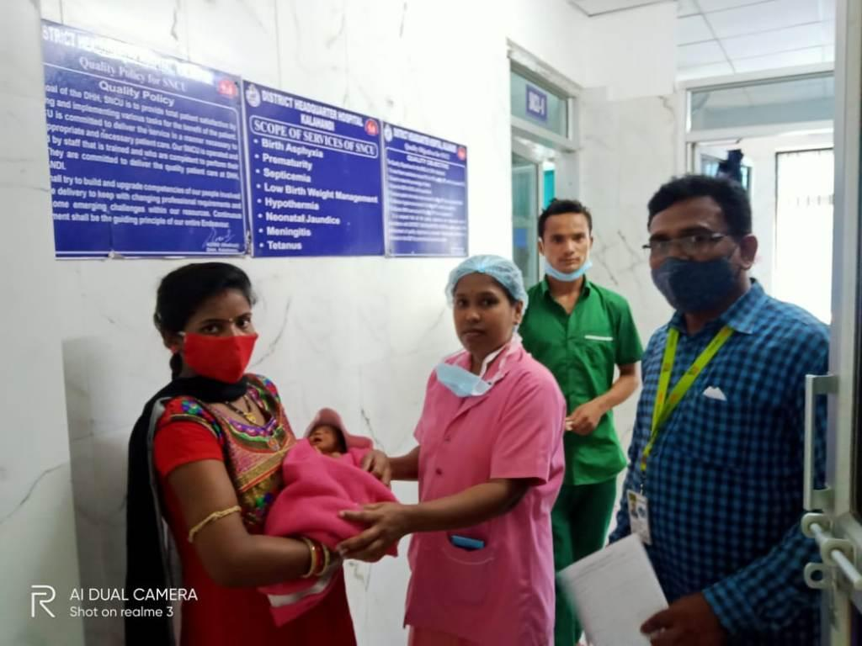
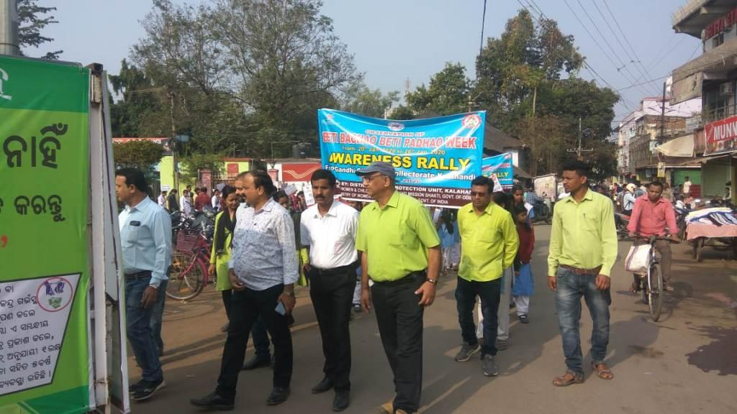
Month | Adolescent girls meeting | Children club Formation | No of Outreached | Children Club Meeting | Volunteer | Event
April 2021 | 3 | 1 | 48 | 3 | 5 | 0
May 2021 | 0 | 0 | 9 | 0 | 5 | 0
June 2021 | 0 | 0 | 51 | 0 | 5 | 0
July 2021 | 2 | 1 | 55 | 0 | 5 | 0
August 2021 | 1 | 2 | 55 | 3 | 5 | 0
September 2021 | 0 | 1 | 55 | 0 | 5 | 0
October 2021 | 0 | 1 | 43 | 0 | 5 | 1
November 2021 | 0 | 1 | 37 | 0 | 5 | 1
December 2021 | 0 | 4 | 50 | 2 | 5 | 2
January 2022 | 1 | 2 | 50 | 0 | 5 | 2
February 2022 | 0 | 4 | 55 | 1 | 4 | 0
March 2022 | 0 | 0 | 54 | 1 | 5 | 1
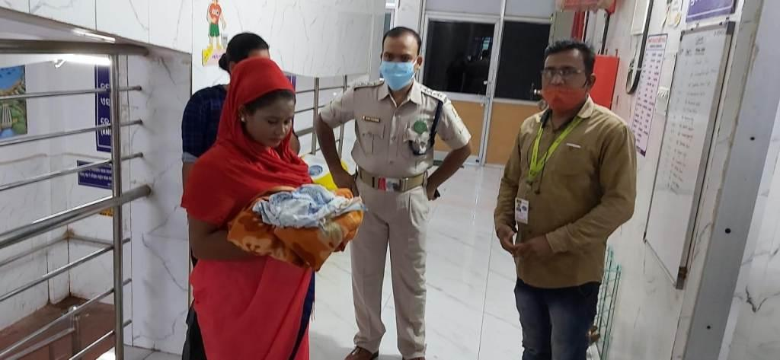

Advocacy & Humanitarian Support
COVID SUPPORT
Supported by Azim Premji Foundation
Witnessing drastic Covid situation and lock down all over country in 2020-21, DAPTA has supported food relief and sanitization material to 11000 house hold those are belonging to returnee migrants, ultra-poor all over Kalahandi. In this program many a donor partner like Azim Premji Foundation, The Hunger Project, Jiv Daya Foundation, Smile Foundation and Habitat India had provided their noble support to people. It was a great help. After lockdown period DAPTA observed people are reluctant to take covid vaccine due to several cause. DAPTA started to work in 10 GP of Lanjigarh Block on covid vaccination with the support of Azim Premji Foundation. The program was of short duration of six month from Nov21 to April 22 in which we have achieved our goal.
In the meantime, SELCO Foundation has supported and added few programs with our vaccination drive in villages. They supported to sensitize people through cultural program and through mass meetings. The support of Selco foundation in shape of dry food to the vaccinated person and to provide transport facility to eligible people to the vaccine center was quite helpful to achieve the target.
COVID Support
In addition to the above the other Covid response activities carried out as per the following.
- Dry Ration, 3-layer cotton mask, soaps and hand sanitizers distributed to 3500 families covering the 130 villages including the 80 operational villages with the support of Azim Premji Foundation.
- Covid Antigen Test conducted in the Community Health Care Centre Mushanal run by DAPTA with the support of Selco Foundation.
- Covid Vaccination drive carried out in 9 Gram Panchayats of Lanjigarh Block covering 121 villages with the support of Azim Premji Foundation. This activity was carried out jointly by the health administration and DAPTA to ensure 100% vaccination of the people within the age of 18 years and above. The achievement is as follows

Tabular data
VACCINATION STATUS 9 GP OF LANJIGARH BLOCK
Sl.no | G P | Nos of village | Target Population | Achievement 1st Dose | Achievement 1st Dose (%) | Achievement 2nd Dose | Achievement 1st Dose (%)
1 | Kumkhal | 14 | 1443 | 1428 | 98 | 1286 | 88
2 | Kankutru | 16 | 1774 | 1768 | 99.6 | 1500 | 84.5
3 | Bandhapari | 20 | 2488 | 2469 | 99 | 2073 | 83
4 | Lanjee | 30 | 3494 | 3481 | 99 | 3209 | 90
5 | Bedagaon | 20 | 1284 | 1267 | 98 | 1056 | 82
6 | Biswanathpur | 15 | 2936 | 2900 | 98.77 | 2523 | 85.9
7 | Bhatangpadar | 26 | 1436 | 1417 | 98.67 | 1278 | 88.99
8 | Pokharibandha | 30 | 2232 | 2198 | 98.47 | 1592 | 71
9 | Bengaon | 29 | 3169 | 3052 | 96.31 | 2604 | 82.17
 |  | 200 | 20256 | 19980 | 98.63 | 17121 | 84.52

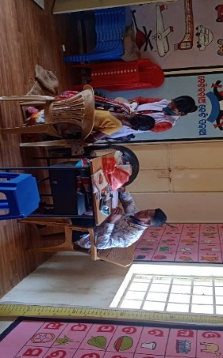
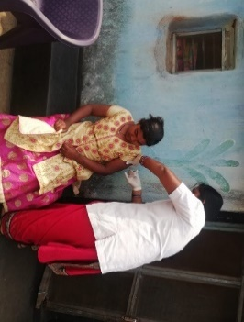
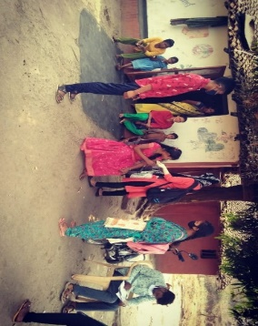
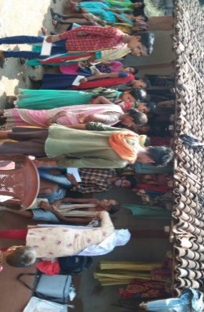
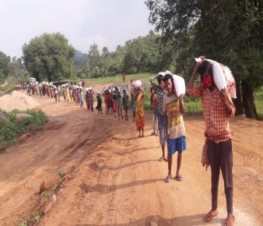
Covid-19 Relief Distribution and Vaccination Drive
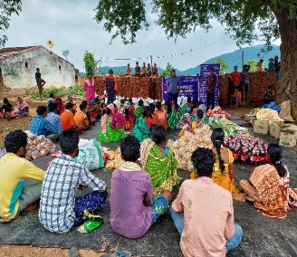
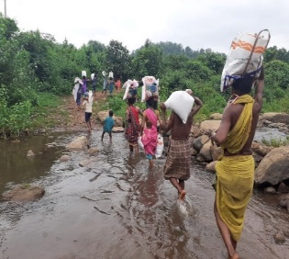
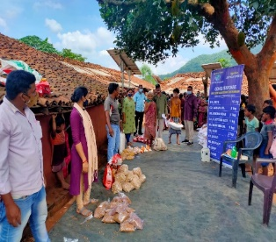
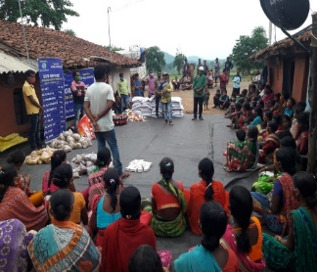

Details of the Governing Board/Exec. Committee

Sl. No | Full Time Office Bearer with Address | Educational Qualification | Professional Qualification | Current Designation/ Work Responsibilities | Years of Work Experiences | Area of Specialization
 | Mrs. Alaka Nayak | M.A | Educationalist and Social Worker | President | 13 Years | Community Mobilization and Communication
 | Mrs. Mamata Mohapatra  Mandar Bagichapada,  Bhawanipatna, Kalahandi. | M.A | Social Worker | Vice-President | 10 | Women Empowerment and Social Development
 | Mr. Rajkishor Sharma  At- Mandar Bagicha pada  Post- Bhawanipatna  Dist.- Kalahandi | M. Com, LLB & MSW | Legal & Development Professional | Secretary cum Chief Functionary | 32 | Community Empowerment and social Development
 | Mrs. Saraswati Mishra  At- Madanmohan Pada  Post- Bhawanipatna  Dist.- Kalahandi | B. A | Women in Agriculture, sustainable Livelihood. | Treasurer | 15 | Social Development
 | Mr. Hrudananda Majhi  At- Lakshmipur  Post- Parmanandapur  Dist.- Kalahandi | B. A | Social Worker | GB Member | 15 | Social Development
 | Mrs. Belmati Naik  Dumal  Kamthana  Bhawanipatna  Kalahandi | Matric | Community mobilization | GB Member | 12 | Education & Social Development
 | Mr. Parsuram Sabar  Batua  Po Gunduri  Kalahandi, | Matric | Social Worker | GB Member | 12 | Social Development
STAFF DETAILS OF DAPTA
No. of Male Staff | No. of Female Staff | No. of TG Staff | Total No. of Staff | No. of Paid Volunteers
67 | 38 | 01 | 106 | TG-5  Women- 45  Total - 50

TRAINERS ASSIOCIATED WITH DAPTA

SL.  NO. | NAME | EDUCATION QUALIFICATION | EXPERIENCE IN DEVELOPMENT SECTOR | SPECIALIZATION
1. | Dipan Kumar Sharma | M.A in sociology. | 18 years in Development sector | RCH, HIV/AIDS, Micro-plan, livelihood and Disaster management, Malaria Control State level trainer in PRI.
2. | Hrudananda Majhi | B. A | 18 years in Development sector. | Agriculture, Watershed, Micro plan and Community Management.Organic farming.
3. | Saraswati Mishra | B. A | 12 years in Development sector. | Agriculture, SHG, Micro plan, PRA, PRI and GKS, Gender Equity. Organic farming.
4. | Srimukh Pan | B. A | 10 years’ experience in Development sector. | Agriculture, SHG, PRI, Micro plan and GKS.
5. | Subhranshu Majhi | M.S. W | 6 years’ experience in Development sector | HIV/AIDS, Health and Livelihood
6. | Tribhuban Pujahari | M.S. W | 15 years | Women Empowerment, Child right, PRI
7. | Bitan Kumar Sharma | M.A | 6years | Women Empowerment, Livelihood, Education and Child Right
8. | Madhabilata Bag | M.S. W | 2 years | Women Empowerment, Livelihood, Education and Child Right
9. | Asish Kumar Mohanty | M.S. W | 6 years | Livelihood
10. | Subhranshu Majhi | M.S. W | 1 year | Health and Child Right
12. | Biswanath Harijan | MSW | 6 years’ experience in Development sector | Health and Education

Legal Entity
Name of the Organization | DEVELOPMENT AGENCY FOR POOR & TRIBAL AWAKENING (DAPTA)
Year of Establishment  Registration details Act.  Reg. No.-  Date-  Type of organization | 15.08.1989  - Society Registration Act XXX 1860  KLD.469-20-1991  23.01.1990.  NGO – Non-Political, Secular and Nonprofit motive social service organization.  b) Registered under Foreign Contribution Act.  Regd. No. -104950021. Dated-17.08.1992 and renewed on dated 01.04.2022  (c) Registered under Income Tax Act  PAN – AAAAD2331A  TAN – BBND00682D  Regd. No-Judl/10/12A/94-95/19773. Dated- 10.09.1995 and renewed on dated 28.05.2021 bearing number-AAAAD2331AE20214  (d) Registered under 80G of Income Tax Act  Regd. No- Judl/119/80G/1995-96/15855. Dated-24.10.1995 & renewed on 28.05.2021 bearing number AAAAD2331AF20214  Regd. No-CIT/SBP/Tech./80-G/2011-12/304 Dated, Sambalpur, the 19th April, 2011 and renewed on dated 28.05.2021  Regd under Nitti Aayog- OR/2016/0101255  Regd under CSR 1- CSR 00006456 of dated 22/05/21

We convey our heartfelt gratitude to all friends, well-wishers, donors and resource agencies and above all the community we work with for their kind & benevolent support and cooperation and travelling with us in the development journey.

Our Bankers |  |  | Our Auditor
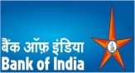  Bank of India  Palace Road  Bhawanipatna  PIN-766001  Dist.- Kalahandi |   Canara Bank Bhawanipatna, Kalahandi |   State Bank of India , NDMB Parliament Street, New Delhi |   C.A. S. Hussain  Mob No. 067262  BHAWANIPATNA, Kalahandi  ODISHA- 766001
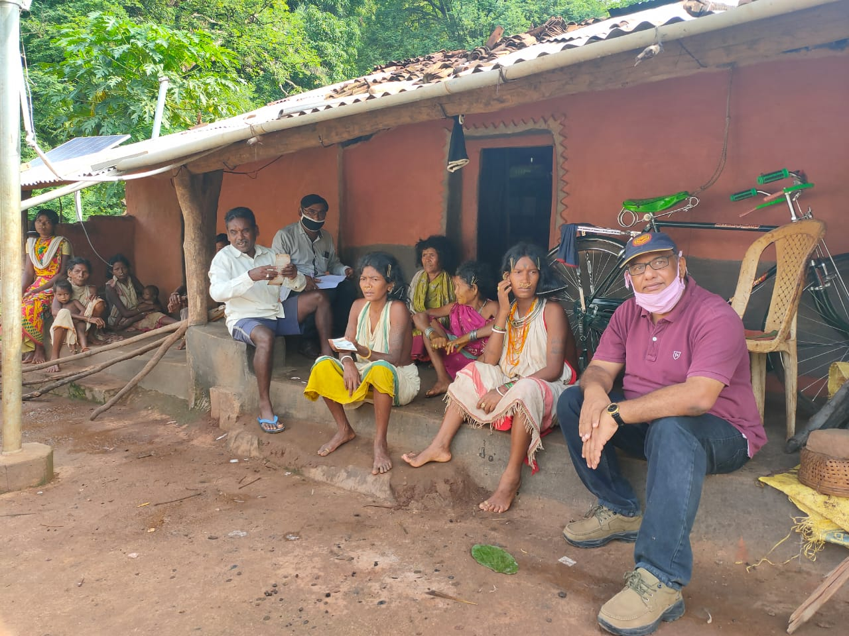

Act of sacrifice, charity and penance
Are not to given/up
They must be performed
Indeed, Sacrifice, Charity and penance
Purify the great soul.

Raj Kishor Sharma,
Secretary, DAPTA

